# C3- S8 PRACTICE

# Flowchart to Boolean expression

Example

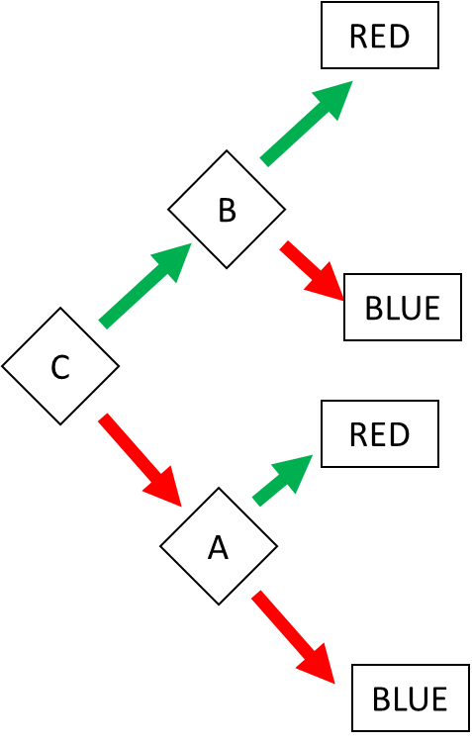

Answer:

RED = (C and B) or (!C and A)

BLUE = (C and !B) or (!C and !A)

# Ex 1: Find the Boolean expression of BLUE

BLUE = A!BC or AB!C or !A!DB

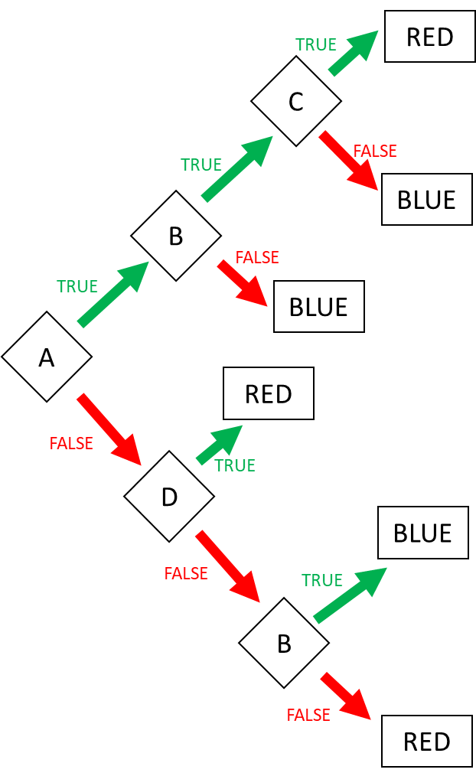

# Ex 2: Find the Boolean expression of BLUE

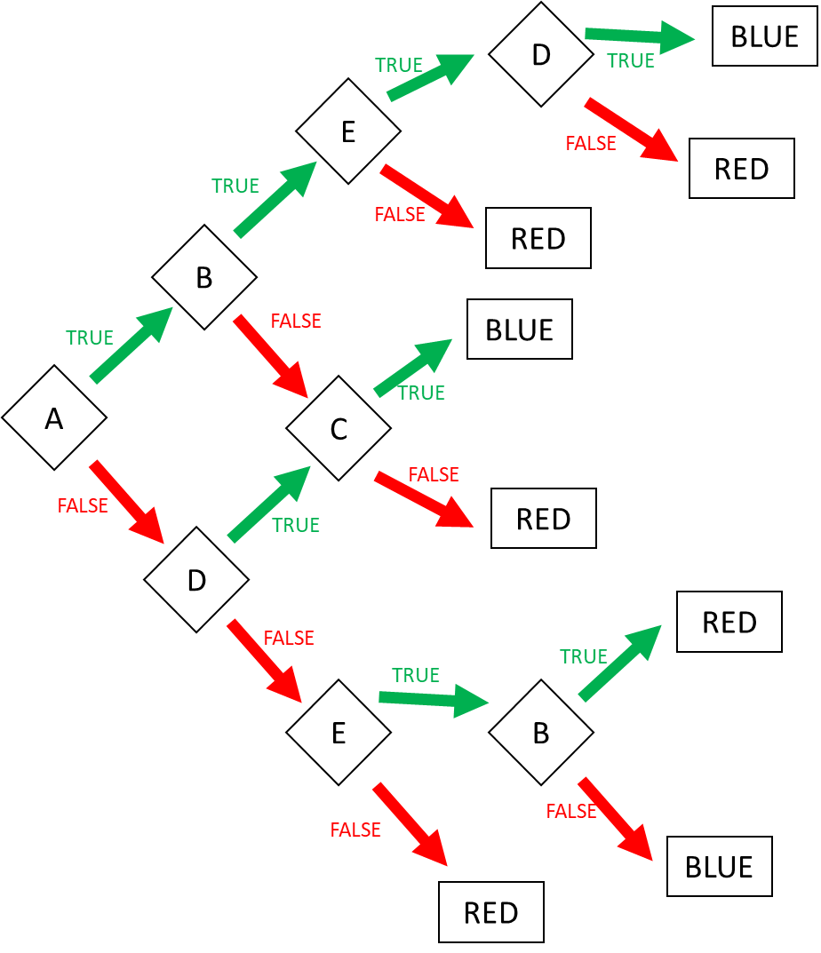

BLUE = ABED or A!BC or !ADC or !A!DE!B

Ex 2: Create the flowchart according to the expressions (4 flowcharts):

1. Go to the market = AB or !A!C
2. Go to swim = ( Sunny AND Sunday) OR ( !(Sunny) and Monday and no homework)
3. I’m superman = A!BCD or AB!CD or !ABCD
4. Happy = ABC!DE!F or A!BCD!EF or !ABCD!E or !A!BC

# 1D range colors

Example:

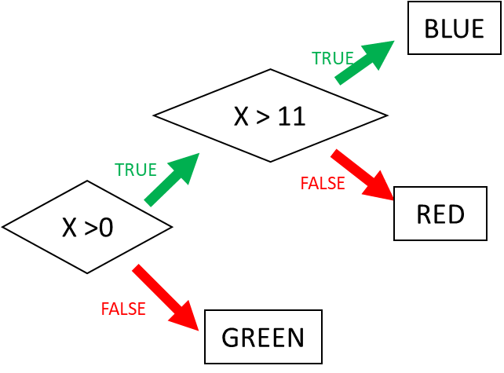

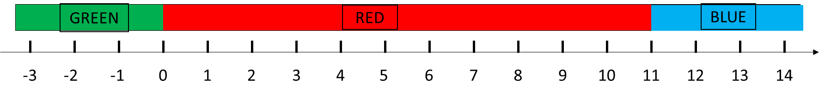

Ex 3: Ranges (1)

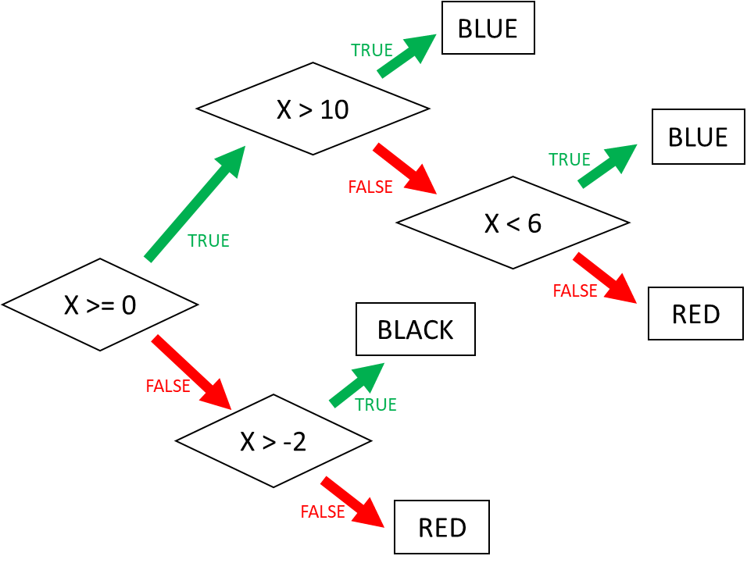

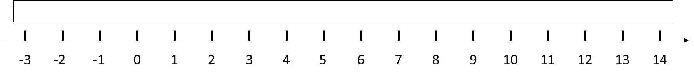

Ex 4: Ranges (2)

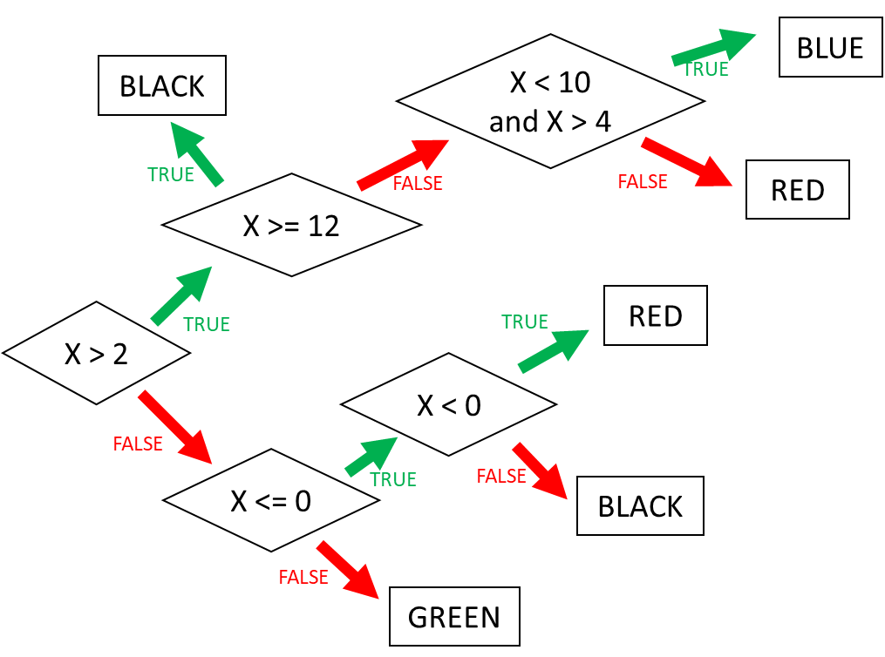



# 2D range colors

Example:

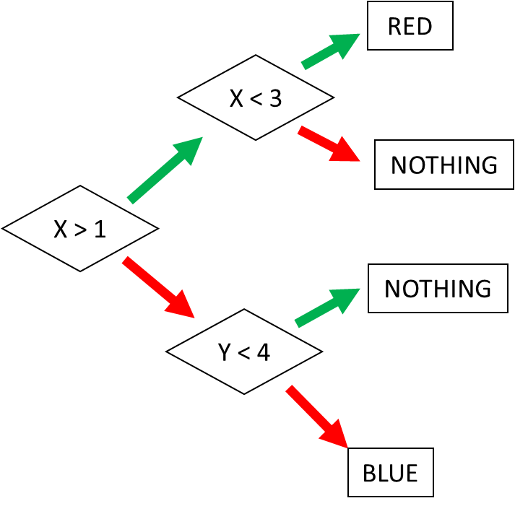 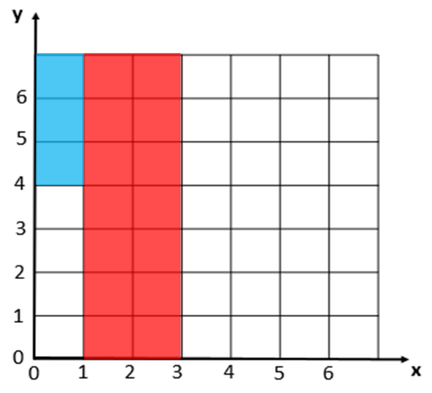

Ex 5: Square (1)

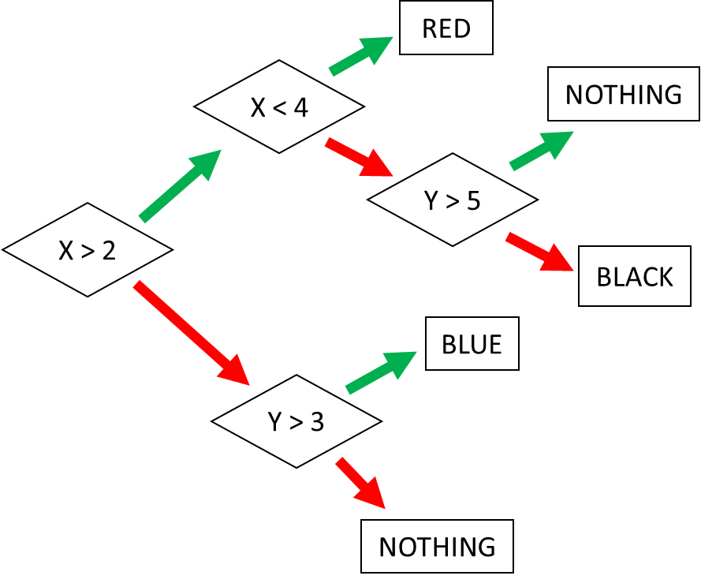 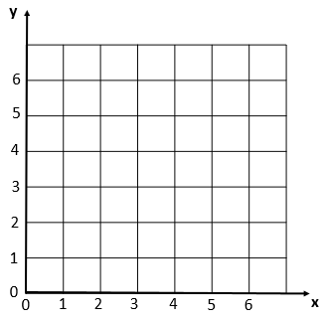

Ex 6: Square (2)

